WOLVEY VILLAGE HALL FOUNDATION
The Square, Wolvey LE10 3LJ

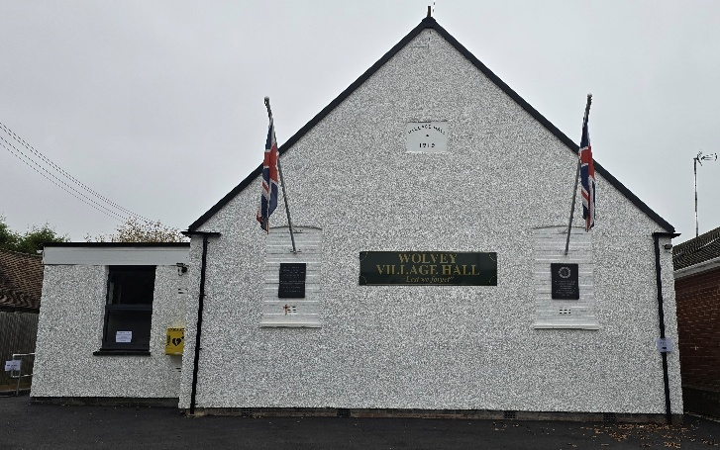

May is the fifth month of the year and is 31 days long, it is also the last month of Spring. It’s birthstone is the emerald and the birth flower is the Lily of the Valley, the Zodiac signs are Taurus and Gemini. We have the May day bank holiday on the 4th and the Spring Bank Holiday on the 25th. Local election day is on the 7th, for election of councillors to Rugby Borough Council Wolvey & Shilton Ward.

Now is also the time to give an early reminder to all of those amongst us who may need to start growing their produce, collecting materials and generally preparing for our 5th Garden and Craft Show, taking place on Sunday 23rd August.

Events happening in May:
For regular events see our “What’s On” poster on notice boards around the village, on facebook or the website. The village hall will be used as a Polling Station on the 7th.There will be Yoga on the 15th, Messy Church on the 17th and the ever popular Community Café on Tuesday 19th.

Monthly Coffee Mornings
Funds raised at the Coffee Morning on Friday 3rd April were shared with the Village hall foundation a registered charity and the Coventry and North Warwickshire Prostate cancer support Group. The coffee morning was very popular and well supported, including representatives from the prostate cancer support group, where a total of over £450 was raised, with a share after expenses amounting to £204.46 was donated to their cause. Just to remind you that the Charity Coffee Mornings are held on the first Friday of each month between 10.30am and 12.30pm, and everyone is welcome. The next event will be on Friday 1st May where we will be supporting Zoe’s Place.

What we have been up to in April:
We started with the Messy Church an the 3rd, community café on the 21st and Yoga on the 26th along with the regular other activities, which included Pilates, Easy Exercise, Martial Arts, Yoga, T’ai Chi, Brownies, Wolvey Woofers, Bridge, Table Tennis, Short Mat Bowls, Tiny Talk Baby Class, Choir rehearsal, plus a host of private events where individuals or groups hired the hall for their own events.

VOLUNTEERING: Wolvey Village Hall is a registered Charity run by volunteers. We have a great team but additional volunteers are always welcome, why not give it a go. It’s a good way to meet new people and put something back into your community. If you can help or are interested in joining us and would like more information, please email admin@wolveyvillagehall.co.uk.

ROOM HIRE AND EVENTS
If you are looking for a venue for your class, group or event please visit our website www.wolveyvillagehall.co.uk for further details (scroll down the pages to see all the information). We offer special rates with generous discount for regular groups which are open to the public and benefit the community (please enquire for details). If you wish to view the venue or have further queries, please contact us at admin@wolveyvillagehall.co.uk.

Availability of rooms, hire charges, terms and conditions and all our policies may be found at our website.
In addition to the above contacts, Telephone enquiries can be made on 07880 807056

Wolvey Village Hall Foundation CIO - Charity No. 1193439

