WOLVEY VILLAGE HALL FOUNDATION
The Square, Wolvey LE10 3LJ

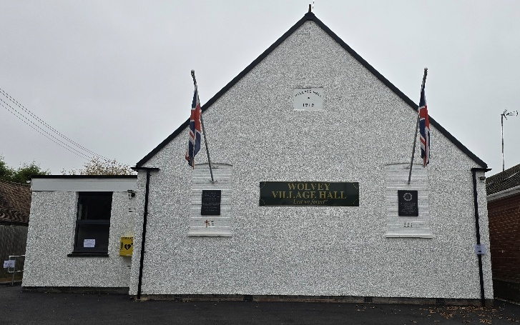

March, the third month of the year, the month in which the spring equinox occurs on Friday the 20th, thus marking the official start of spring in the northern hemisphere. It also marks the start of British Summer Time, when the clocks spring forward 1 hour on the 29th, where both sunrise and sunset will be about 1 hour later than before.

Events happening in March:
For regular events see our “What’s On” poster on notice boards around the village, on facebook or the website. The ever popular Community Café will take place on Tuesday 17th March and the main event for the village hall is the Spring Craft Fair featuring on Saturday the 21stMarch, when we will have lots of craft and artisanal stalls in the main hall, from 10.30am to 3pm.

Monthly Coffee Mornings
Funds raised at the Coffee Morning on Friday 6th February were shared with the Village hall foundation a registered charity, where the funds went towards the refurbishment of the hall floor.

The upcoming Coffee Morning will be on Friday 6th March and will see funds raised shared with the Warwickshire Wildlife Trust. Just to remind you that the Charity Coffee Mornings are held on the first Friday of each month between 10.30am and 12.30pm, and everyone is welcome.

What we have been up to in February:
The refurbishment of the village hall floor was completed, which involved sanding the surface down to a new level and applying three coats of high quality, two-part lacquer. This was then allowed to dry and harden and has provided a beautiful new floor. This came in at a cost of just over £5,000 and we thank you all for your support and donations which enabled us to do this.

This was followed on Tuesday 17th February with another Community Café, where everyone enjoyed the food and drinks and the general social occasion. The Choir rehearsal nights also re-convened after the Christmas break.

Other activities included Pilates, Easy Exercise, Martial Arts, Yoga, T’ai Chi, Brownies, Wolvey Woofers, Bridge, Table Tennis, Short Mat Bowls, plus a host of private events where individuals or groups can hire the hall for their own events.

VOLUNTEERING: Wolvey Village Hall is a registered Charity run by volunteers. We have a great team but additional volunteers are always welcome, why not give it a go. It’s a good way to meet new people and put something back into your community. If you can help or are interested in joining us and would like more information, please email admin@wolveyvillagehall.co.uk.

ROOM HIRE AND EVENTS
If you are looking for a venue for your class, group or event please visit our website www.wolveyvillagehall.co.uk for further details (scroll down the pages to see all the information). We offer special rates with generous discount for regular groups which are open to the public and benefit the community (please enquire for details). If you wish to view the venue or have further queries, please contact us at admin@wolveyvillagehall.co.uk.

Availability of rooms, hire charges, terms and conditions and all our policies may be found at our website.

Contact us: www.wolveyvillagehall.co.uk admin@wolveyvillagehall.co.uk

https://www.facebook.com/wolveyvillagehallfoundation

Wolvey Village Hall Foundation CIO - Charity No. 1193439

