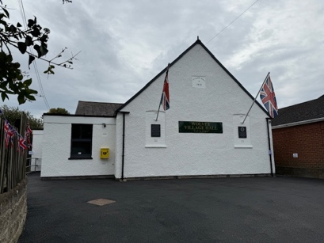
WOLVEY VILLAGE HALL FOUNDATION (CIO)
The Square, Wolvey LE10 3LJ

February seems to have rushed by in the blink of an eye and we have only a few weeks before we put the clocks on an hour. The days are stretching out and it feels as though we have more time to do things, so why not plan ahead and see what’s on for you at your Village Hall.

WE HAVE THREE NEW EVENTS FOR YOU TO ENJOY IN MARCH:


On Friday, 7 March 2025 Nrithyam School of Dance are celebrating Women’s Day and invite you to join them at Wolvey Village Hall for a cross-cultural evening featuring:
✨ Mesmerising Indian Dance Performances
💃 A Fun Dance Workshop – Learn & Move with Us!
🎶 Groovy DJ & Music
🍛 Delicious Dinner
From: 7.00pm-10.00pm. Ticket Price: £23 per person
Register here: https://forms.gle/Ab2hK8AZEmMgy3nu5
For further information call: Karthikeyan Durairaj – 07846 721631 or
Swapna Velayudham – 07593 259369

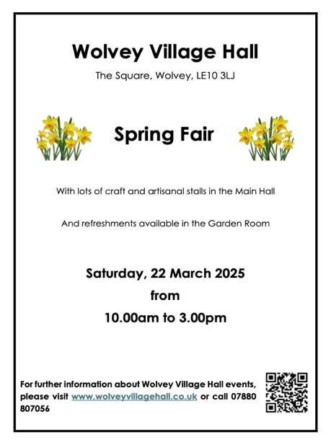
Saturday, 22 March 2025
Wolvey Village Hall Spring Fair
From 10.00am to 3.00pm
Lots of craft and artisanal stalls
Refreshments available
We still have availability
If you would like a stall please contact us
by email below

Friday, 28 March 2025
Sound Bath, Yoga and Meditation
In the Garden Room
From 7.30pm-9.00pm
Contact Naomi on 07857 916140
or email naom2travel@yahoo.co.uk
£15pp

Further details for all the above may be found on our Facebook page.

Also, don’t forget that Messy Church is on Sunday, 23 March from 3.30pm-5.00pm. All welcome, no charge but donations welcome. Fun for all the family.

MONTHLY COFFEE MORNINGS

Our nominated charity for the Coffee Morning on 7 February was Mary Ann Evans Hospice and £245.70 was raised for this wonderful charity.

The 7 March Coffee Morning funds raised will be shared between the Village Hall and Doorway. Members of the community are also invited to bring to the Hall any donations of clean/new household items, i.e. bed linen, towels, crockery, cutlery, kitchen utensils, pots and pans, cleaning items, which will be delivered to Doorway after the Coffee Morning.

The Village Hall Coffee Mornings are held on the first Friday of each month between 10.30am and 12.30pm, and everyone is welcome. Mini Explorers for babies, pre-school children and their carers is held in the Garden Room and is a great way to make new friends or spend time with old friends.

SOUP AND ROLL LUNCHES

Our final Soup and Roll lunch of the season will be held on 18 March from 12.15-2.15pm. These have proven increasingly popular through the winter, with patrons enjoying Clare’s delicious home-made soup. It’s so good the local Police came along to the February event with three PCSOs joining the diners and engaging with local residents. Thank you to Clare and to all the volunteers who give up their time each month and without whom we couldn’t provide this wonderful service to the community.

At the same time as the Soup and Roll on 18 March, Warwickshire Library Service will be visiting with their Tea & Tech support. Should you need help online or have any tech questions, bring along your device (laptop/tablet/phone) and they will give you direction and advice in what you want to do. Whether it’s online shopping, making a doctor’s appointment, booking tickets, writing emails and more, they will be able to guide you through it. You can come along just for this session or you can enjoy the delicious soup while you’re there.

EASY EXERCISE CLASSES

Although the Soup and Roll will be ending, our Easy Exercise classes are still going strong every Tuesday, and these are followed by tea, coffee and biscuits for all those who wish to stay. Come along between 11.00-11.45am and join in this fun exercise – no pressure, move at your own level. You’ll be amazed at the improvement in just a few weeks.

VOLUNTEERING

Wolvey Village Hall is a registered Charity run by volunteers. We have a great team but additional volunteers are always welcome, particularly for our monthly Coffee Mornings. If you would like to join us please get in touch by email (below) or speak to one of the volunteers or Committee Members at any of our events. It’s a great way to meet new people and put something back into your community.

ROOM HIRE AND EVENTS

If you are looking for a venue for your class, group or event please visit our website www.wolveyvillagehall.co.uk for further details (scroll down the pages to see all the information). We offer special rates with generous discount for regular groups which are open to the public and benefit the community (please enquire for details). If you wish to view the venue or have further queries, please contact us at admin@wolveyvillagehall.co.uk.

Availability of rooms, hire charges, terms and conditions and all our policies may be found at our website.

Contact us: www.wolveyvillagehall.co.uk admin@wolveyvillagehall.co.uk

https://www.facebook.com/wolveyvillagehallfoundation

Wolvey Village Hall Foundation CIO - Charity No. 1193439

