WOLVEY VILLAGE HALL FOUNDATION
The Square, Wolvey LE10 3LJ

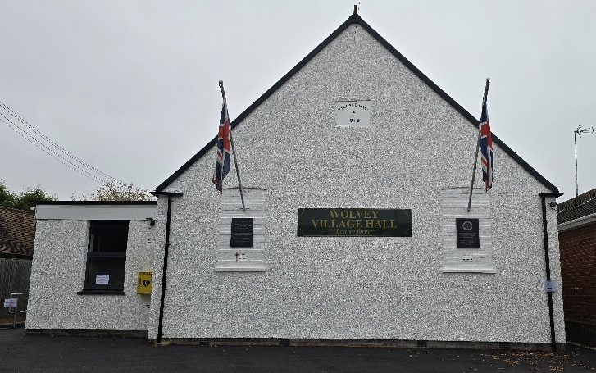

Welcome to October and the continuation into Autumn, where the nights are starting to draw in by around 5 minutes per day and it will be on Sunday 25th when the clocks go back.

Events happening in October:
For regular events see our “What’s On” poster on notice boards around the village, on facebook or the website. The poppy crochet and knitting group will be meeting up every Wednesday through October from 2pm until 4pm to make poppies for the Remembrance display. On Sunday 10th there is a Harvest Supper and Quiz, a church fund raising event, including a ploughmans supper and on Sunday 18th there’s Messy Church.

On Saturday 24th is the return of the ever popular music evening featuring the superb band “Off the Cuff”.

Monthly Coffee Mornings
Funds raised at the Coffee Morning on Friday 4th September were shared between the Village hall foundation a registered charity and the Redgate Farm Animal Sanctuary, where we raised £475.08 which after costs of £48, enabled us to hand over 213.54. A representative from Redgate Farm attended and he was able to visit each table to have chat and give information about the charity, who also have a charity shop in Castle Street to raise funds for their cause.

Just to remind you that the Charity Coffee Mornings are held on the first Friday of each month between 10.30am and 12.30pm, and everyone is welcome, the next event will be on Friday 2nd October, when funds raised will be shared with Macmillan Cancer Support, doing whatever it takes to help more people with cancer get the best care the UK has to offer, whoever and wherever they are.

What we have been up to in September:
We held the ever popular community café on the 15th, The Stanley Opera Company put on their production of The Gondoliers on the 27th, and the poppy crochet and knitting group commenced. Other regular activities, which included Pilates, Easy Exercise, Martial Arts, Yoga, T’ai Chi, Brownies, Wolvey Woofers, Bridge, Table Tennis, Short Mat Bowls, Tiny Talk Baby Class, Choir rehearsal, Messy Church, plus a host of private events where individuals or groups hired the hall for their own events.

VOLUNTEERING: Wolvey Village Hall is a registered Charity run by volunteers. We have a great team but additional volunteers are always welcome, why not give it a go. It’s a good way to meet new people and put something back into your community. If you can help or are interested in joining us and would like more information, please email admin@wolveyvillagehall.co.uk.

ROOM HIRE AND EVENTS
If you are looking for a venue for your class, group or event please visit our website www.wolveyvillagehall.co.uk for further details (scroll down the pages to see all the information). We offer special rates with generous discount for regular groups which are open to the public and benefit the community (please enquire for details). If you wish to view the venue or have further queries, please contact us at admin@wolveyvillagehall.co.uk.

Availability of rooms, hire charges, terms and conditions and all our policies may be found at our website.
In addition to the above contacts, Telephone enquiries can be made on 07880 807056

Wolvey Village Hall Foundation CIO - Charity No. 1193439

