WOLVEY VILLAGE HALL FOUNDATION
The Square, Wolvey LE10 3LJ

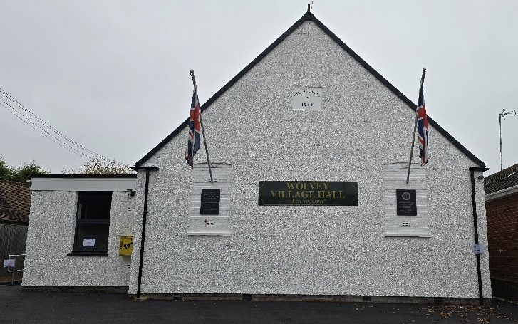

Welcome to September and the official start of Autumn, hopefully we will continue to enjoy some sunny weather for a while. September also sees the end of the school summer holidays, with both Leicestershire and Warwickshire schools returning by the time this publication goes out. A very successful 5th Garden and Craft Show was held towards the end of August, more about that later.

Events happening in September:
For regular events see our “What’s On” poster on notice boards around the village, on facebook or the website. There will be the Yoga, Meditation and Soundbath on Sunday 13th, the ever popular Community Café on Tuesday 15th. On Thursday 17th it is exercise classes redirected from Shilton, while their floor is being restored and on Sunday 20th there’s Messy Church.

On Sunday 27th at 2.30pm the Stanley Opera Group on Tour will be presenting “The Gondoliers”, Gilbert and Sullivans riotous comedy with some beautiful music.

One advance notice for October 24th is the return of the ever popular music evening featuring the superb band “Off the Cuff”.

Monthly Coffee Mornings
Funds raised at the Coffee Morning on Friday 3rd July were shared between the Village hall foundation a registered charity and the Air Ambulance (donation of £181), who deliver rapid emergency care to communities including Warwickshire and Leicestershire, a letter of thanks was received from them. On the coffee morning of 7th August funds raised were shared between the Village hall foundation and the Wolvey Brownies (donation of £235), the volunteers at our coffee morning had extra help from the local brownies, they did a brilliant job helping to serve tea and cakes and we really appreciated their hard work and have arranged for certificates of thanks to be given to every brownie that helped. We were delighted to raise money that will go to both the brownies and the running of the hall.

Just to remind you that the Charity Coffee Mornings are held on the first Friday of each month between 10.30am and 12.30pm, and everyone is welcome, the next event will be on Friday 4th September, when funds raised will be shared with Redgate Farm Animal Sanctuary.

What we have been up to in July and August:
We held the ever popular community café on the 21st July and again on the 18th August, both well supported. Other regular activities, which included Pilates, Easy Exercise, Martial Arts, Yoga, T’ai Chi, Brownies, Wolvey Woofers, Bridge, Table Tennis, Short Mat Bowls, Tiny Talk Baby Class, Choir rehearsal, plus a host of private events where individuals or groups hired the hall for their own events.

5th Garden and Craft Show
The main event for August was the 5th Garden and Craft Show, which took a lot of planning by the volunteers and much cajoling, where many villagers joined in, bringing their home grown produce, along with exhibits of flowers, baking and arts & crafts, which were all judged to reveal the top 3 in each class.

There were 119 people who submitted entries for the show, totalling 420 exhibits, up almost 100 on last year, so although the weather this year was very dry for some produce, everyone rallied around to support the show.

The café was open for tea and cakes, which was very well supported, with most people having a cake and tea. There was the grand raffle, a tombola and a tombola just for children, then in conclusion folk could buy some of the wonderful produce to take home.

A great day was had, with over 170 people attending the show and raising funds totalling £1422, which after covering all costs to put on the event, will go towards keeping the village hall in good working order for the years to come.

So a big thank you to all of the volunteers who made the show work, the exhibitors who without, there wouldn’t be a show and to all those who came and enjoyed the afternoon out.

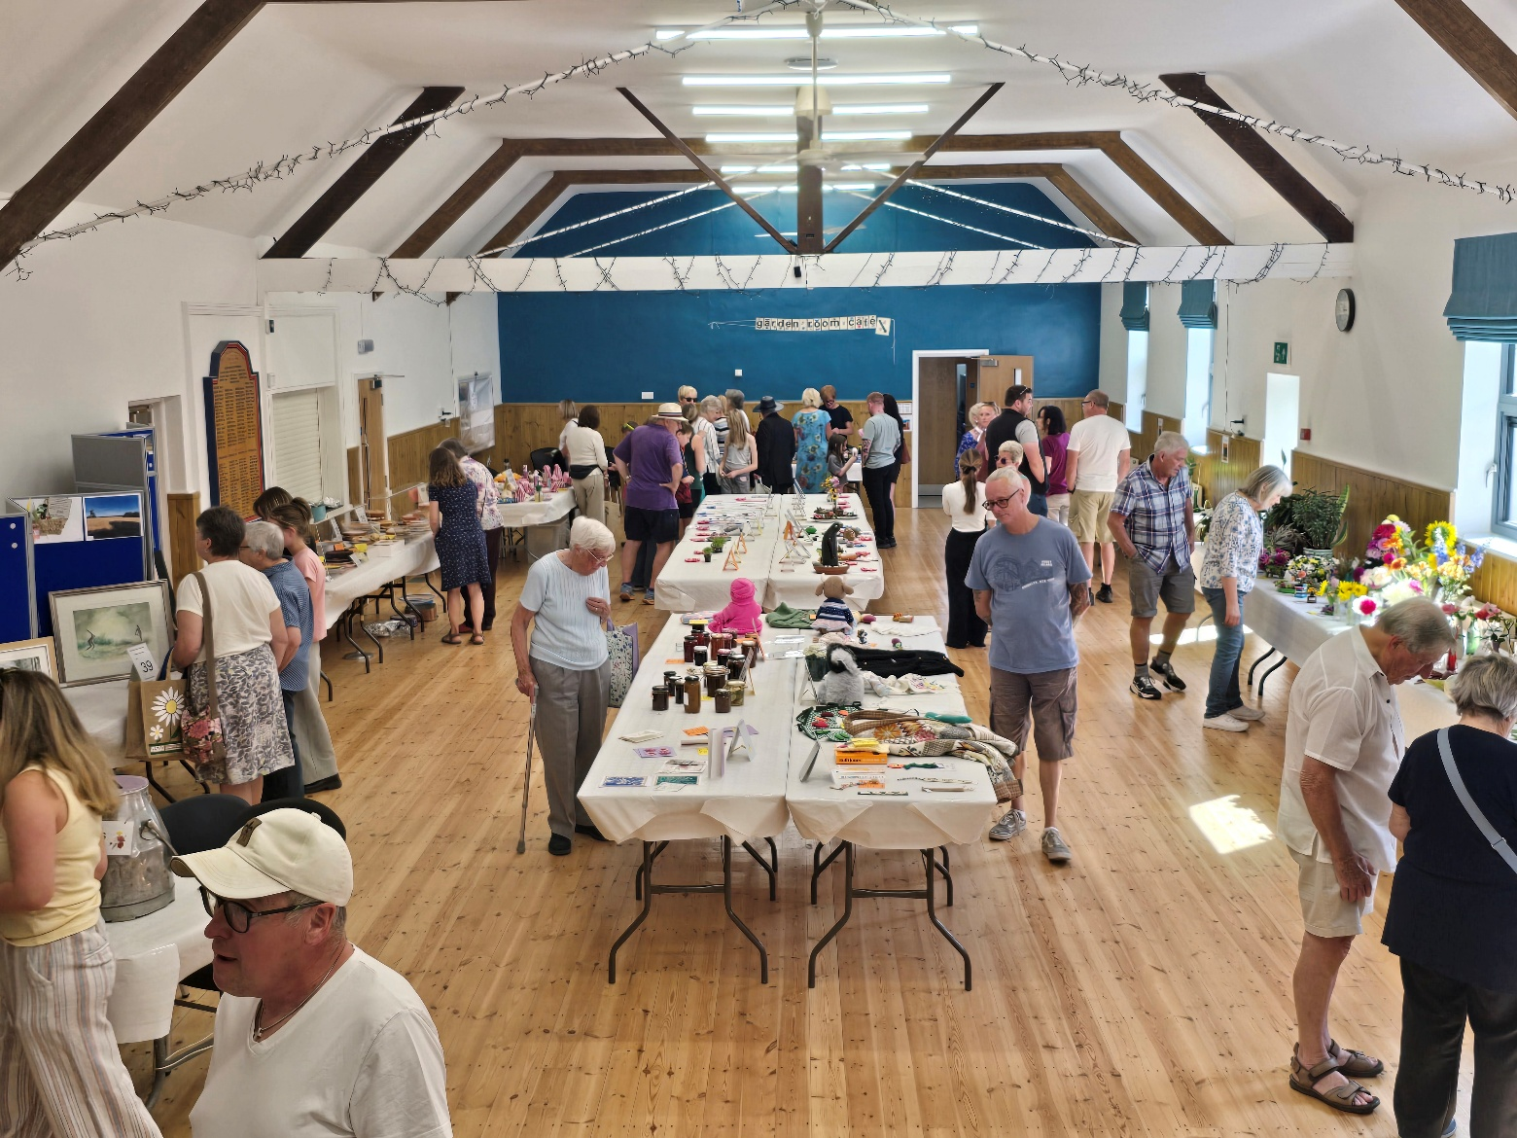

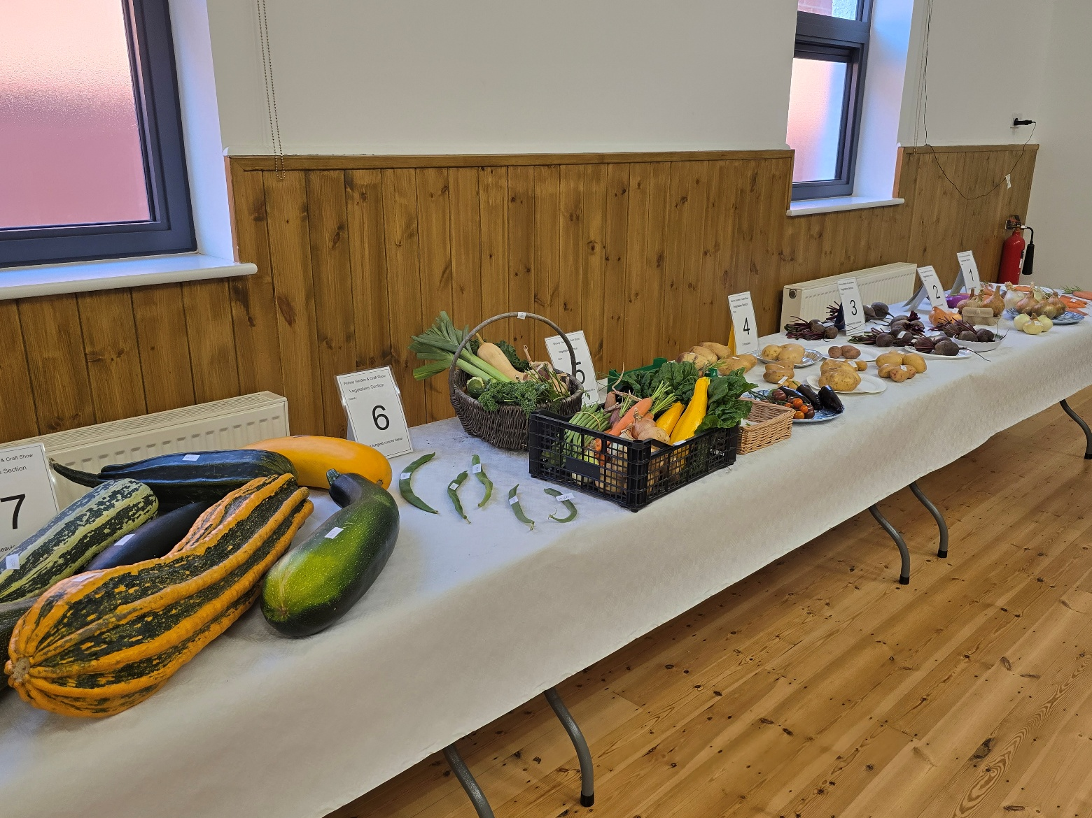

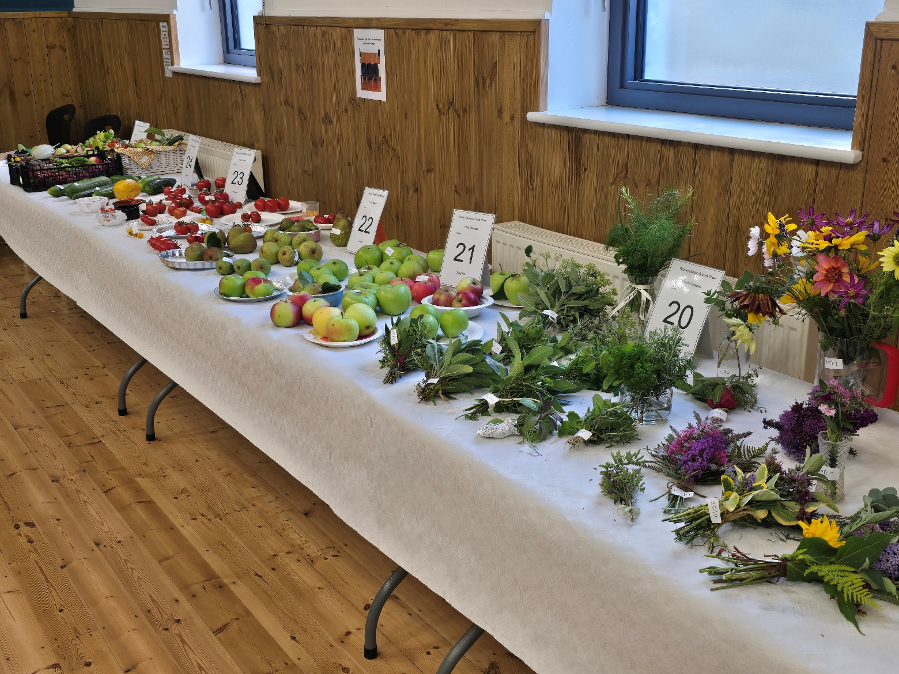
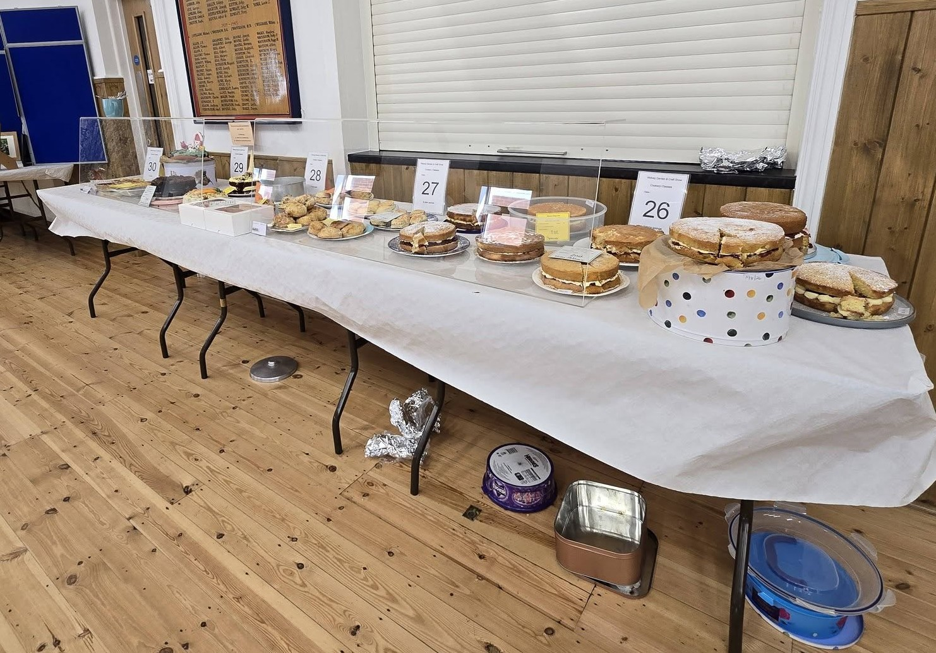

VOLUNTEERING: Wolvey Village Hall is a registered Charity run by volunteers. We have a great team but additional volunteers are always welcome, why not give it a go. It’s a good way to meet new people and put something back into your community. If you can help or are interested in joining us and would like more information, please email admin@wolveyvillagehall.co.uk.

ROOM HIRE AND EVENTS
If you are looking for a venue for your class, group or event please visit our website www.wolveyvillagehall.co.uk for further details (scroll down the pages to see all the information). We offer special rates with generous discount for regular groups which are open to the public and benefit the community (please enquire for details). If you wish to view the venue or have further queries, please contact us at admin@wolveyvillagehall.co.uk.

Availability of rooms, hire charges, terms and conditions and all our policies may be found at our website.
In addition to the above contacts, Telephone enquiries can be made on 07880 807056

Wolvey Village Hall Foundation CIO - Charity No. 1193439

