WOLVEY VILLAGE HALL FOUNDATION
The Square, Wolvey LE10 3LJ

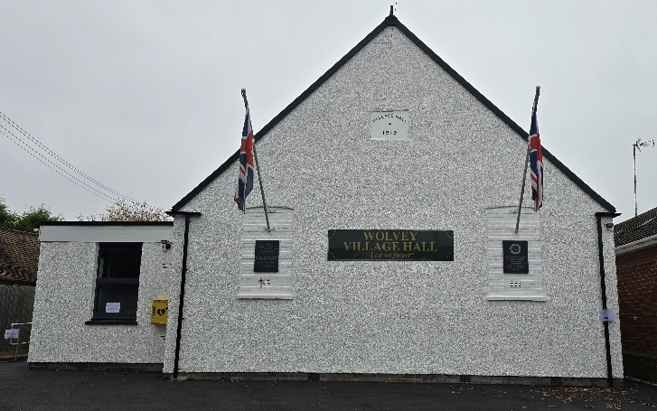

We are well and truly into summer now, hopefully enjoying some of the best weather we have had for a year or two, you never know we may even get used to it before long. This edition of the Link spans two months, July and August, it will also welcome the start of the school holidays, Leicestershire schools close 8th July and Warwickshire schools close 18th July. So please keep a lookout for events for school goers to participate in at the village hall, in particular preparing for our garden and craft show in August where it is all about the taking part.

EVENTS HAPPENING IN JULY:
For regular events see below and our “What’s On” poster on notice boards around the village, on facebook or the website. On Friday 4th we have the charity coffee morning (see below for details). On Tuesday 15th we have our now regular monthly Summer Community Café, supported by Warm Hub, on Sunday 20th there is the Soundbath class from 6pm to 7pm.

EVENTS HAPPENING IN AUGUST:
On Friday 1st it is the Charity Coffee Morning (see below), on Saturday 16th we have an all day event the VJ80 Day History Exhibition.

On Sunday 17th it is our highly acclaimed and much awaited Garden and Craft Show, the culmination of everybody’s hard work to grow produce, bake cakes or make craft items. Your entries will need to be submitted in the morning and then they will be displayed in the afternoon where it will be a fun and joyous occasion for all. We look forward to receiving your entries, they don’t have to be perfect or best in show, it is a community event which is the important part, see poster and schedule of classes available on the website or get a paper copy from the village shop.

Tuesday 19th is the return of the Summer Community Cafe

MONTHLY COFFEE MORNINGS
Our nominated charity for the Coffee Morning on Friday 6th June was Emmaus, a charity supporting adults who are homeless or vulnerable. The event was well supported and after expenses taken out, we were able to donate £178.62 to the charity, so well done all.

The upcoming Coffee Mornings will see, in July, funds raised shared between the Village Hall and Zoe’s Place, a Baby Hospice providing care and support in Coventry and in August the Nuneaton and Warwickshire Wildlife Sanctuary, who rescue and rehabilitate sick or trapped wildlife, for both events your continued support will be much appreciated. Just to remind that the Coffee Mornings are held on the first Friday of each month between 10.30am and 12.30pm, and everyone is welcome.

EASY EXERCISE CLASSES
Our Easy Exercise classes are still going strong every Tuesday, and these are followed by tea, coffee and biscuits for all those who wish to stay. However on the 15th July and the 19th August the Summer Community Café will run in the Garden Room after the exercise class, meaning that snacks and sandwiches will be available to buy afterwards.

WHAT WE HAVE BEEN UP TO OVER THE PAST FEW WEEKS:

Summer Community Café
On Tuesday 17th June, we had the second airing of the Café in the Garden Room supported by Warm Hub, numbers were up on last month, where people were able to meet, socialise and enjoy the Teas & Coffees, Snacks, Sandwiches and Panini, on offer, all at reasonable prices.

Other activities staged in June included Messy Church, Pilates, Martial Arts, Yoga, T’ai Chi, Brownies, Wolver Woofers, Bridge, Table Tennis, Short Mat Bowls, Soundbath, plus a host of private events where individuals or groups can hire the hall for their own events.

VOLUNTEERING: Wolvey Village Hall is a registered Charity run by volunteers. We have a great team but additional volunteers are always welcome, why not give it a go. It’s a good way to meet new people and put something back into your community. In particular the new Café will need volunteers to help make it a success, if you can help or are interested in joining us and would like more information, please email admin@wolveyvillagehall.co.uk.

ROOM HIRE AND EVENTS
If you are looking for a venue for your class, group or event please visit our website www.wolveyvillagehall.co.uk for further details (scroll down the pages to see all the information). We offer special rates with generous discount for regular groups which are open to the public and benefit the community (please enquire for details). If you wish to view the venue or have further queries, please contact us at admin@wolveyvillagehall.co.uk.

Availability of rooms, hire charges, terms and conditions and all our policies may be found at our website.

Contact us: www.wolveyvillagehall.co.uk admin@wolveyvillagehall.co.uk

https://www.facebook.com/wolveyvillagehallfoundation

Wolvey Village Hall Foundation CIO - Charity No. 1193439

