WOLVEY VILLAGE HALL FOUNDATION
The Square, Wolvey LE10 3LJ

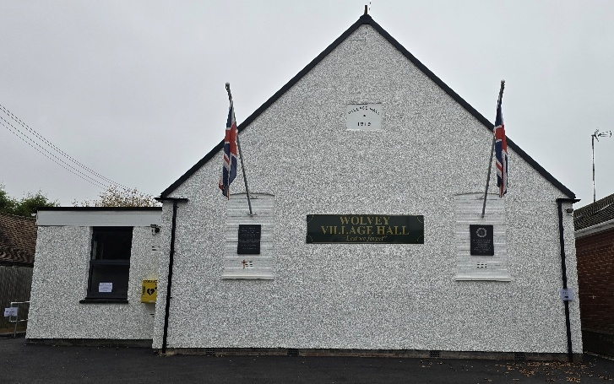

So to February, the second month of the new year, with only 28 days again this time, the next leap year being 2028. We have had a busy time at the hall over Christmas and the new year, culminating in a closure of the hall at the end of January for floor restoration works, where the hall re-opens on Monday 2nd February.

Events happening in February:
For regular events see our “What’s On” poster on notice boards around the village, on facebook or the website. There are no major events taking place in February, although the hall will be busy with the regular bookings and private do’s. The ever popular Community Café will take place on Tuesday 17th February.

Monthly Coffee Mornings
Funds raised at the Coffee Morning on Friday 5th December were shared with the Salvation Army and after expenses our donation amounted to £193.68, thanks to all those who attended and supported our fundraising event. The following month the coffee morning took place on 2nd January and funds raised were shared with the Leicestershire and Rutland Samaritans and our donation amounted to £142.71.

The upcoming Coffee Morning will be on Friday 6th February and will see funds raised go to the Village Hall floor restoration fund to help with the costs of renovating the floor, which was essential maintenance to keep the village hall going and cost over three thousand pounds. Just to remind you that the Charity Coffee Mornings are held on the first Friday of each month between 10.30am and 12.30pm, and everyone is welcome.

What we have been up to in December and January:

On the 7th Dec the village hall played host to the annual Christmas tree lights switch-on event for Wolvey villagers, with refreshments, presents for children and displays by local groups. On Tuesday 16th Dec we had another successful Community Café, where folk came to enjoy the home made soup, panini and for the first time jacket potatoes with different toppings were on offer.

On Sunday 18th January we had a great afternoon of music from Assetto Acappella a barbershop quartet, which included a cream tea and a raffle that all went down very well.

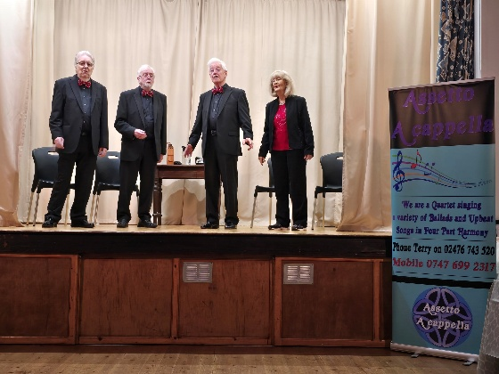

This was followed on Tuesday 20th January with another Community Café, numbers continue to grow and we had our best attendance yet, where everyone enjoyed the fayre and general social occasion.

The newly established Community Voices Ladies Choir rehearsal nights re-convened on the 22nd January after a break over the Christmas period.

Other activities included Pilates, Easy Exercise, Martial Arts, Yoga, T’ai Chi, Brownies, Wolvey Woofers, Bridge, Table Tennis, Short Mat Bowls, plus a host of private events where individuals or groups can hire the hall for their own events.

VOLUNTEERING: Wolvey Village Hall is a registered Charity run by volunteers. We have a great team but additional volunteers are always welcome, why not give it a go. It’s a good way to meet new people and put something back into your community. If you can help or are interested in joining us and would like more information, please email admin@wolveyvillagehall.co.uk.

ROOM HIRE AND EVENTS
If you are looking for a venue for your class, group or event please visit our website www.wolveyvillagehall.co.uk for further details (scroll down the pages to see all the information). We offer special rates with generous discount for regular groups which are open to the public and benefit the community (please enquire for details). If you wish to view the venue or have further queries, please contact us at admin@wolveyvillagehall.co.uk.

Availability of rooms, hire charges, terms and conditions and all our policies may be found at our website.

Contact us: www.wolveyvillagehall.co.uk admin@wolveyvillagehall.co.uk

https://www.facebook.com/wolveyvillagehallfoundation

Wolvey Village Hall Foundation CIO - Charity No. 1193439

