WOLVEY VILLAGE HALL FOUNDATION
The Square, Wolvey LE10 3LJ

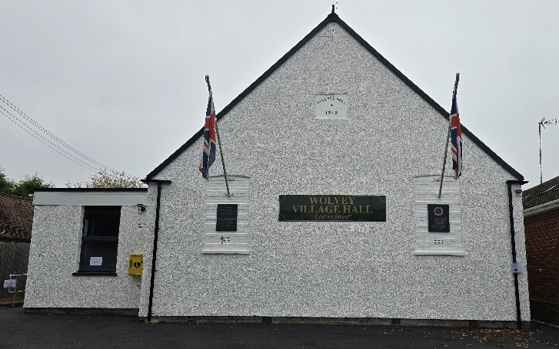

June is the 6th month of the year, consisting of 30 days and is named after the Roman goddess Juno (the wife of Jupiter), it also marks the beginning of summer and contains the summer solstice (21st June), which is the day with the most daylight hours. But fear not, there will hopefully be many long sunny hours of daylight to come over the summer months.

EVENTS HAPPENING IN JUNE:
Every Thursday evening we have a new weekly addition to our programme namely the MB Yoga sessions (7.15 – 8.15pm). On Friday 6th we have the charity coffee morning (see below for details). On Sunday 8th there is Messy Church from 3pm – 5pm. On Tuesday 17th we have the second airing of our new Warm Hub venture, the Summer Community Café (see below for more details). On Sunday 22nd there is another Yoga class the Mudras Meditation and Soundbath, then on 29th it is Yoga Meditation and Soundbath with Naomi

MONTHLY COFFEE MORNINGS
Our nominated charity for the Coffee Morning on Friday 2nd May was the Armed Forces charity SSAFA in conjunction with our VE Day themed street party styled layout. The event was a great success with everybody embracing the occasion, and joining in on the celebrations. Donations raised were with the SSAFA charity.

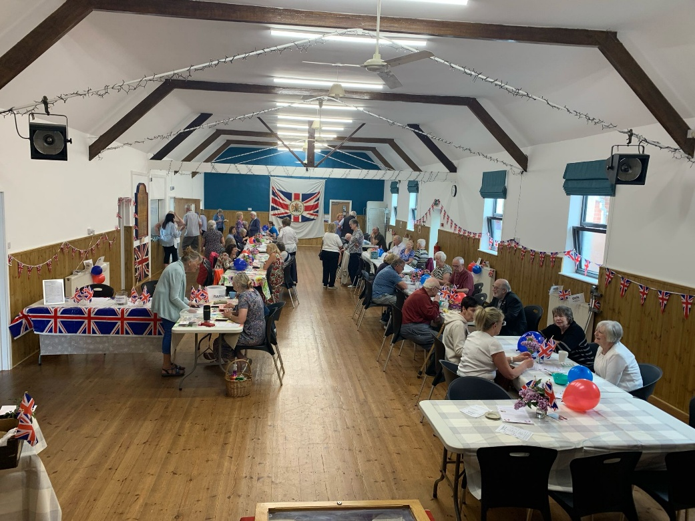

The upcoming 6 June Coffee Morning will see funds raised shared between the Village Hall and Emmaus, a charity supporting adults who are homeless, vulnerably housed or at risk.

The Village Hall Coffee Mornings are held on the first Friday of each month between 10.30am and 12.30pm, and everyone is welcome. Mini Explorers for babies, pre-school children and their carers is held in the Garden Room and is a great way to make new friends or spend time with old friends.

EASY EXERCISE CLASSES
Our Easy Exercise classes are still going strong every Tuesday, and these are followed by tea, coffee and biscuits for all those who wish to stay. However on the 17th June the Summer Community Café will run in the Garden Room alongside and after the exercise class, meaning that snacks and sandwiches will be available to buy afterwards.

WHAT WE HAVE BEEN UP TO OVER THE PAST FEW WEEKS:
On Thursday 8th May the Local History Group held an open afternoon in the Garden Room and displayed many wartime local photos from 1945, which proved to be very interesting, with many local names highlighted as being involved in the war effort.

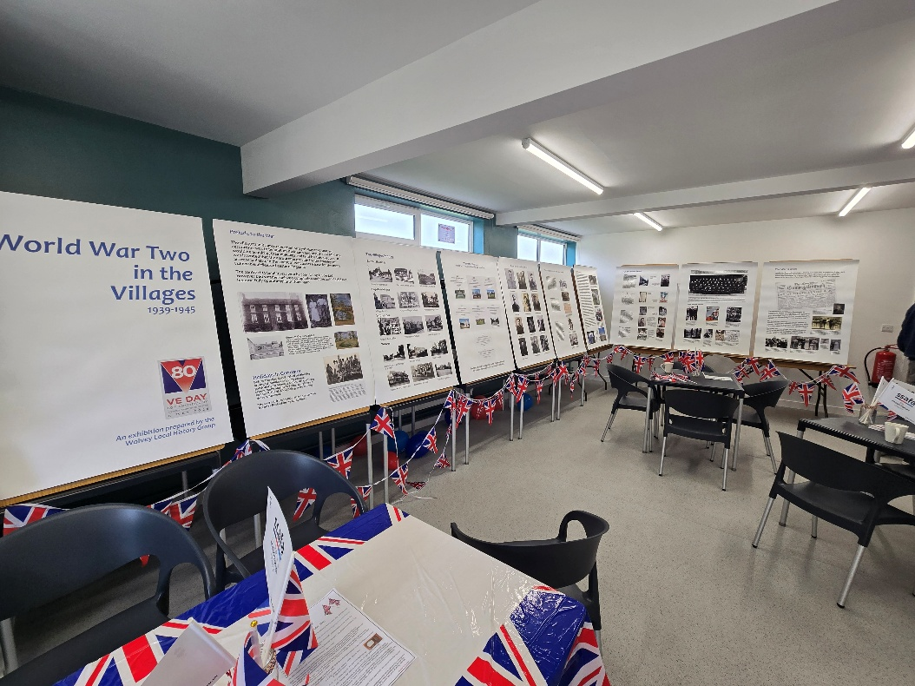

This was followed by Rugby Borough Council making a presentation as to why they are proposing 710 new houses within Wolvey village.

Summer Community Café
On Tuesday 20th May in the Garden Room we opened our brand new Summer Community Cafe, which will be an ongoing feature through the summer months (third Tues of the month). The Community Cafe is a new initiative supported by Warm Hubs, a place for people to meet and socialise. The café will be run by volunteers, serving Teas & Coffees, Snacks, Sandwiches and Panini, all at reasonable prices, just drop in and a warm welcome will be extended to you. As well as being a meeting place we will also be developing pastimes and activities, where it will become a place to play dominoes, crib or other games. We may also organise a Jigsaw and Book swap for you and your friends to browse, whilst enjoying the fayre on offer at the Cafe.

As with our coffee mornings, parents and children will be most welcome, we would love the children to take advantage of the garden whilst mums and dads have a cup of tea. We would welcome any suggestions for pastimes/ activities that friends would like to play or arrange.

VOLUNTEERING: Wolvey Village Hall is a registered Charity run by volunteers. We have a great team but additional volunteers are always welcome, why not give it a go. It’s a good way to meet new people and put something back into your community. In particular the new Café will need volunteers to help make it a success, if you can help or are interested in joining us and would like more information, please email admin@wolveyvillagehall.co.uk.

ROOM HIRE AND EVENTS
If you are looking for a venue for your class, group or event please visit our website www.wolveyvillagehall.co.uk for further details (scroll down the pages to see all the information). We offer special rates with generous discount for regular groups which are open to the public and benefit the community (please enquire for details). If you wish to view the venue or have further queries, please contact us at admin@wolveyvillagehall.co.uk.

Availability of rooms, hire charges, terms and conditions and all our policies may be found at our website.

Contact us: www.wolveyvillagehall.co.uk admin@wolveyvillagehall.co.uk

https://www.facebook.com/wolveyvillagehallfoundation

Wolvey Village Hall Foundation CIO - Charity No. 1193439

