WOLVEY VILLAGE HALL FOUNDATION
The Square, Wolvey LE10 3LJ

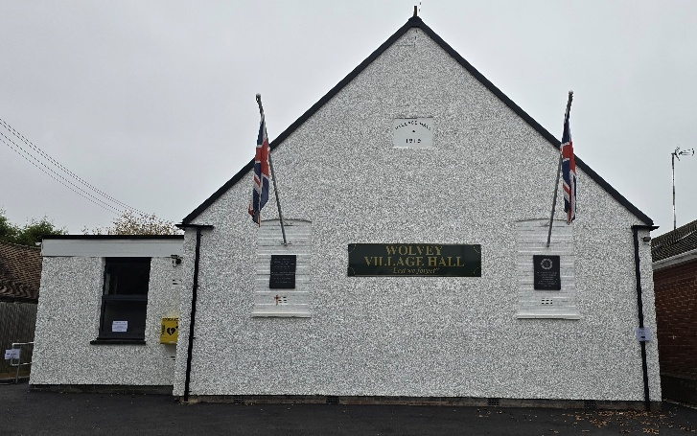

April, the fourth month of the year, it’s birthstone is the diamond and the birth flower is the common daisy, the Zodiac signs are Aries and Taurus. April 1st is April Fools Day, so be aware.

Events happening in April:
For regular events see our “What’s On” poster on notice boards around the village, on facebook or the website. The ever popular Community Café will take place on Tuesday 21st April.

Monthly Coffee Mornings
Funds raised at the Coffee Morning on Friday 6th March were shared with the Village hall foundation a registered charity, and the Warwickshire Wildlife Trust where a total of £200.33 was donated to their cause. Just to remind you that the Charity Coffee Mornings are held on the first Friday of each month between 10.30am and 12.30pm, and everyone is welcome. The next event will be on Friday 3rd April where we will be supporting the Coventry and North Warwickshire Prostate Cancer Support Group.

What we have been up to in March:
We started with the community café on Tuesday 17th March, where everyone enjoyed the food and drinks and the general social occasion.

Our main event in March on Saturday 21st was the Spring Craft fair, a fantastically successful event, with 20 stalls of crafts including, Wildlife and Pet Photography, Doggy Treats, Artworks, Leather Crafts, Artificial Flower Arrangements, Pebbles and Shells, Bags & Scarfs, Glass Crafts and Jewellery, Cards & Papercraft, Jams and Relishes, Wax Melts, Children’s Books, Local Bee Group, Crochet & Knitted Items

We had almost 200 people through the door to enjoy the crafts and make purchases, have teas, coffees, cakes and snacks in the café, partake in the main raffle and the ever popular tombola and making donations, all to support the ongoing sustainability of the village hall. Thanks go to all of the volunteers who made it happen and to those attending to make it such a success.

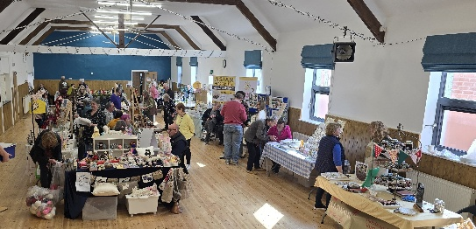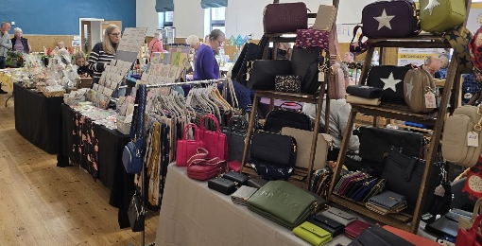

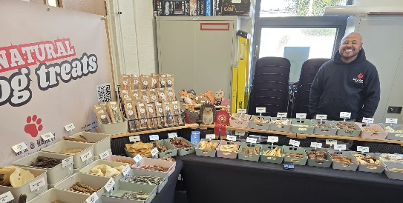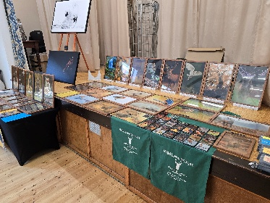

Other activities included Pilates, Easy Exercise, Martial Arts, Yoga, T’ai Chi, Brownies, Wolvey Woofers, Bridge, Table Tennis, Short Mat Bowls, Tiny Talk Baby Class, Choir rehearsal, Messy Church, plus a host of private events where individuals or groups can hire the hall for their own events.

VOLUNTEERING: Wolvey Village Hall is a registered Charity run by volunteers. We have a great team but additional volunteers are always welcome, why not give it a go. It’s a good way to meet new people and put something back into your community. If you can help or are interested in joining us and would like more information, please email admin@wolveyvillagehall.co.uk.

ROOM HIRE AND EVENTS
If you are looking for a venue for your class, group or event please visit our website www.wolveyvillagehall.co.uk for further details (scroll down the pages to see all the information). We offer special rates with generous discount for regular groups which are open to the public and benefit the community (please enquire for details). If you wish to view the venue or have further queries, please contact us at admin@wolveyvillagehall.co.uk.

Availability of rooms, hire charges, terms and conditions and all our policies may be found at our website.

Contact us: www.wolveyvillagehall.co.uk admin@wolveyvillagehall.co.uk

https://www.facebook.com/wolveyvillagehallfoundation

Wolvey Village Hall Foundation CIO - Charity No. 1193439

